Documentation for the Covid-19 Dashboard
The COVID Dashboard is accessed by going to the Ribbon Bar, choosing Reports, Clicking on the Custom Reports button, and then clicking on the ‘COVID-19 Reports’ button.
Contents:
- What does the ordinary user have to do?
- Using the COVID-19 Dashboard
  - Filling in the Dates
  - Running the Error Check
  - Generating an Excel Spreadsheet for LSC
  - Generating other LSC Reports
  - Other available reports
- Other ways to access C19 information
  - Search Screens
  - Criteria Screens
- Where does the TC19 field show up?

- What does the ordinary user have to do?
Except for one additional field, the ordinary user will not have to do anything different than they are currently doing. However, since the report to LSC depends upon certain fields, it would be best to review the new field and how it is used.

  - There is a new TC19 field (Transfer COVID-19). This field does three things:
    - It insures the field is entered by the user. The default is:
‘000 Not Entered’
So you can monitor this field being used by looking for 000.

    - It identifies the case as having a C19 legal issue or not.
If the case has a C19 issue, the value of this field is changed to 001, 002 or 003. This tags the case as having a C19 legal issue. If the case has a 000, it means the intake person did not fill this field out. If it has a 999, it means the case does not have a C19 legal issue as part of it.

    - It identifies the funding source for handling the case, irrespective of the normal funding code. This field has four possible entries:

‘000’ Not Entered
This is the default value for the field and insures that the intake person checks to see if there is a C19 legal issue involved. If there isn’t the TC19 field is changed.

‘999’ No Covid Legal Issue
This is the entry that occurs if there is no C19 Legal Issue involved in the case.

‘001’ LSC Covid funding
The user puts this value in where the case is being handled using special LSC C19 funding.

‘002’ LSC Other funding
This entry is used where there is a C19 legal issue but the case is using normal LSC funding, rather than that designated for C19 cases.

‘003’ Other funding
This value is used where funding from another source other than LSC is used to handle a case with a C19 issue.

  - What tables are affected?
There are six tables that have the TC19 field as part of them, and one that is affected by the field.

    - ClientsW
The Clients table is used to generate the opened and closed case report for LSC. It is important that the user fill out a birth date, mark the client a being a veteran (or not), and fill out the TC19 field. The other fields for this report are also normally required. They are gender, case type (PBI or Staff), reason closed (if a closed case), problem code and ethnicity.

    - Eligibility
The Eligibility table is used to track those C19 legal issue cases rejected and not handled. The TC19 field can be used to designate the funding source that the case would have fit in. Having a 001, 002 or 003 in the field shows that the case has a C19 issue. It is important that a Reason Rejected is filled out. This is used to track that the case has been rejected. A report of the number of these cases is required by LSC.

    - Callback
Callback is provided with a TC19 field because different programs use Callback different ways. If it is used to prescreen a case, it might count as a rejection of a C19 case and thus be similar to the Eligibility Slip. It might also be used to do an early identification of a C19 legal issue.

    - Other Services
LSC wants to track and report on Other Services provided concerning C19 legal issues. This is limited to codes 101, 102 and 103. Also we added a code 200 to handle one additional service. These are laid out below.
101 | Presentations to community groups
102 | Legal education brochures
103 | Legal education materials posted on web sites
200 | Legal Ed/Outreach to Bar Groups & Other Prof Group

    - Ttime
There is no current requirement to track staff time in C19 cases. However, it is possible that this requirement might be imposed by LSC in the future. It is also possible other funding sources might require it. Since making this change was relatively easy while making the other changes, the TC19 field is included as part of the time record.

    - Ttime PBI
There is no current requirement to track PBI time in C19 cases. However, it is possible that this requirement might be imposed by LSC in the future. It is also possible other funding sources might require it. Since making this change was relatively easy while making the other changes, the TC19 field is included as part of the PBI time record.

    - Litigation Expenses
Although not having a TC19 field, the Litigation Expenses Special Program can be used to track any expenses on a C19 case. This is because the Litigation Expenses table is associated by case number with the Client record. It can thus be easily identified as applying to a C19 Case.

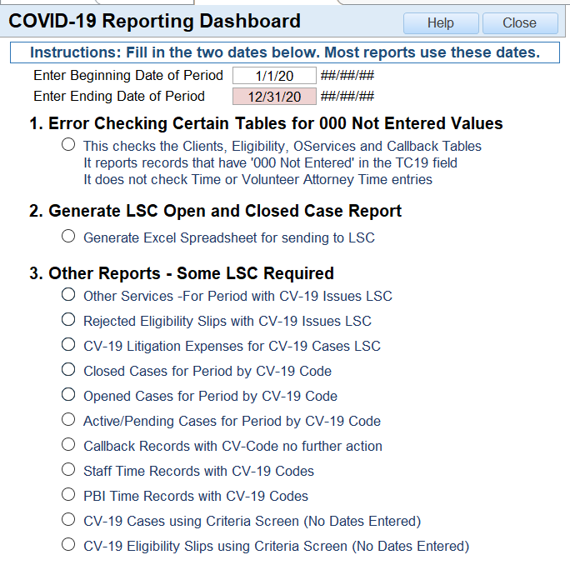

- Using the COVID-19 Dashboard
The COVID-19 Dashboard is where you get the reports you need and send the data to LSC. It is the place where you access the tools you need.

- Filling in the Dates
The first thing that you need to do is fill in the dates. ALL of the reports on the screen, except for the two that use the Criteria screen and say ‘No Dates Entered’ depend upon these dates to select the data you want.

- Running the Error Check
The system is designed to make your job easier by insuring your staff enters the type of funding for the C19 issue, or enter that there isn’t a C19 issue (999)

- Generating an Excel Spreadsheet for LSC
The second choice is to generate a spread sheet for LSC. This is generated immediately. You can get a copy of the spreadsheet file three ways:
      - If your drive is mapped through document tracking (hosted) can pull it off the Venture Disk
      - When the spreadsheet appears on the screen, copy and paste the cells into your own Excel Spreadsheet, save it and send it
      - Pick it up off your disk if you are locally hosted.

- Generating other LSC Reports
The system generates three other reports for LSC.
  - The first is the Other Services for a period. It uses 101, 102 and 103, counting number of services and people helped for the first requirement. Then it uses a new Service, 200 which is 'LegalEd/Outreach to Bar Groups & Other Prof Groups'.
  - The second gives you a list of rejected C19 issues. It uses Eligibility and finds those slips that have a 001, 002 or 003 in the TC19 field and also have a reason rejected.
  - The third Report gathers up your expenses on your C19 cases. It uses the special program, zLitigationExpenses, and lets you gather any expenses incurred on the case. If the list doesn’t include everything you’d like to track, go to zLitigationExpensessub and add any other type of expense you need.

- Other available reports
Since you’ve gathered the information, we’ve provided you with additional reports for internal use or for other funders.
  - Closed cases – This report shows you the Client cases you’ve closed in the period. It provides information such as the client name, staff number, etc. for internal use.
  - Opened cases– This report shows you the Client cases you’ve opened in the period. It provides information such as the client name, staff number, etc. for internal use. A case could show up on this report and a. above if it was opened and closed in the same period.
  - Active or Pending cases– This report shows you the Client cases that were active (open) at any time in the period. It provides information such as the client name, staff number, etc. for internal use.
  - Callback – This report shows you the Callback records that were never sent to a Client or Eligibility slip during the period. If you use Callback to prescreen, you could use these figures to add to your Eligibility cases rejected to show the number C19 cases you’ve turned away. It provides information such as the client name, staff number, etc. for internal use.
  - Ttime – Some funders might require you to track the time spent on C19 cases. This report will show you the time spent on these cases.
  - TtimePBI – Some funders might require you to track the time spent on C19 cases by Volunteer Lawyers. This report will show you the time spent on these cases.
  - The Client report using the Criteria Screen makes it easy to use any field on the Client intake to limit which C19 Cases are displayed.
  - The Eligibility report using the Criteria Screen makes it easy to use any field on the Eligibility intake to limit which C19 Cases are displayed.

- Other ways to access C19 information
The TC19 field is woven into the system and shows up in many locations.
- Search Screens
The C19 Codes can be displayed on any of the search screens for the six tables mentioned above. This field (TC19) shows up in the pull down on both the Client Search Screen and the Eligibilty Search Screen.
- Criteria (QBF)Screens
The Criteria Screens that allow you to use any field on the intake to select cases support the TC19 field and should allow you to run multiple reports using this as a limitation.

      - 001, 002, 003 selects all the C19 cases
      - 000, 999 selects all the non C19 cases
      - 003 selects only cases that have a C19 legal issue and other funding.

- Where does the TC19 field show up?
  - Search Screens – You can use the Search Field pull down on the Clients and Eligibility Search screen to look for C19 cases. You can also change one of the columns to show the TC19 field in all the tables that hold it:
    - Clients
    - Eligibility
    - Callback
    - OService
    - Ttime
    - TtimePBI
  - Input and Print Outs of Input Screens
The TC19 field shows up on all the input screens and print out screens for the following tables. This means, for example, that the TC19 field shows up on all five Time input screens.
    - Clients
    - Eligibility
    - Callback
    - OService
    - Ttime
    - TtimePBI
  - Criteria Screens
The Criteria Screens are QBF (Query by Form) Forms that allow you to search for or limit data by putting a value next to the appropriate field. This means all reports that use these screens can be filled with only cases involving (or not involving) Covid-19 issues if desired.

For example:
999 next to the Covid 19 label would display records without a Covid issue
000 would show records where the input person never filled in a value
001 would show records where special LSC Covid funding was used
001, 002, 003 would show all records with a Covid issue no matter what their funding source was.

COVID shows up as a choice on the Criteria Screens for these tables:
    - Clients
    - Eligibility
    - Callback
    - OService
    - Ttime
    - TtimePBI

